TN-001. SPB Deployment Currents
General. The RBSP EFW IDPU is responsible for deploying the Spin Plane Booms (SPB) and other actuators in the instrument complement. In order to provide a safety against inadvertent actuation, a separate supply is used for Actuations. This supply is turned ON in order to support deployments and turned OFF at all other times. The Actuator supply is OFF at all times when the IDPU is OFF.

The Actuator supply does not see inrush, typically, since all the IDPU switches are open when the supply is turned ON. However, Spin Plane Boom motors will provide significantly varying current profiles which are the subject of this tech note.

It is important to note that this data is taken at room temperature and using test harnessing. Both aspects bias the resulting data set toward smaller currents than might be seen in flight where the bus impedance and wiring is significantly lower impedance.

SPB simulators use real motors with EMI filters as per flight configuration and have a loading device set for worst-case mechanical load.

Configuration. The battery simulator used a 2.5 A power supply with a 0.1F capacitor. These were harnessed to the IDPU ETU, and Flight SPBs 901-904. The test connectors on Flight SPBs were attached by test cable to the SPB simulators. Due to practical considerations, the length of the harnessing into and out of the test area was about 20 feet. The round trip ground impedance from the supply return to the SPB simulator return was measured at 3.9 Ohms.

Figure TN01-1. Test Configuration

Procedure. The test procedure called for opening the Doors and Deploying the wire booms in Single and Paired fashion. The following pages show these waveforms.

Figure 2. SPB Door Open (TiNi Resistive Load)
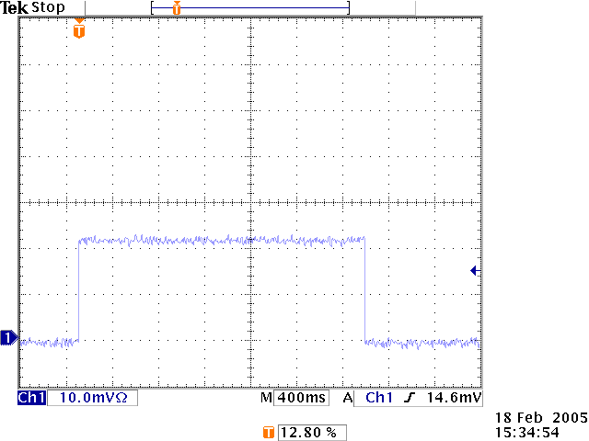

The IDPU is able to fire actuators for a command-able period in units of 250 msec. Under nominal temperatures, the TiNi will be fired for 0.5 second. In the above test, the IDPU was commanded to fire the SPB doors for 2.5 seconds.

The Flight current requirement is 2 A.

Figure 2. SPB Deployment Motor Start Up Current (Single Unit)
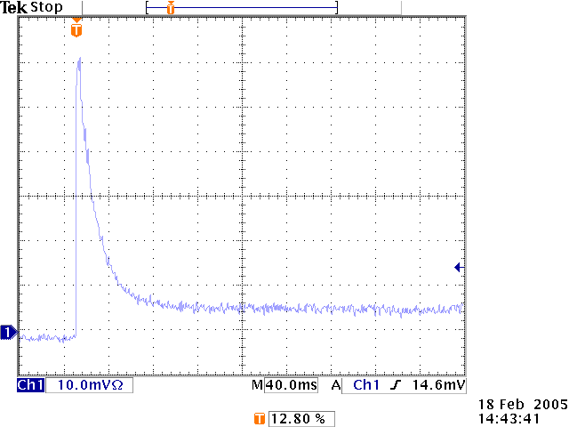

The above curve was taken with a SPB simulator SPB_SIM001.

Turn On. The peak current shown on the plot is 1.03 A. The motor achieves full speed in 80-90 msec.

Nominal. The running current shown on the plot and verified by digital meter is 0.107 A
.

Figure 3. SPB Deployment Motor Start Up Current (Pair)
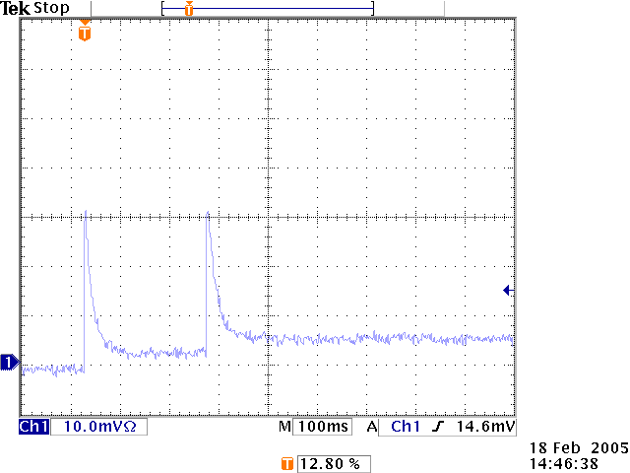

The above curve was taken with a SPB simulator SPB_SIM001 and 002. The IDPU was commanded to deploy both booms in paired fashion. The software separates all turn On's and turn Off's by 250 msec in order to minimize disturbances to the power system.

Turn Ons. The peak current shown on the plot is 1.03 A. Motor 1 starts and will achieve full speed long before Motor 2 start occurs, guaranteeing that the spike for the second motor does not overlay the first.

Nominal. The running current shown on the plot and verified by digital meter is 0.212 A
.

